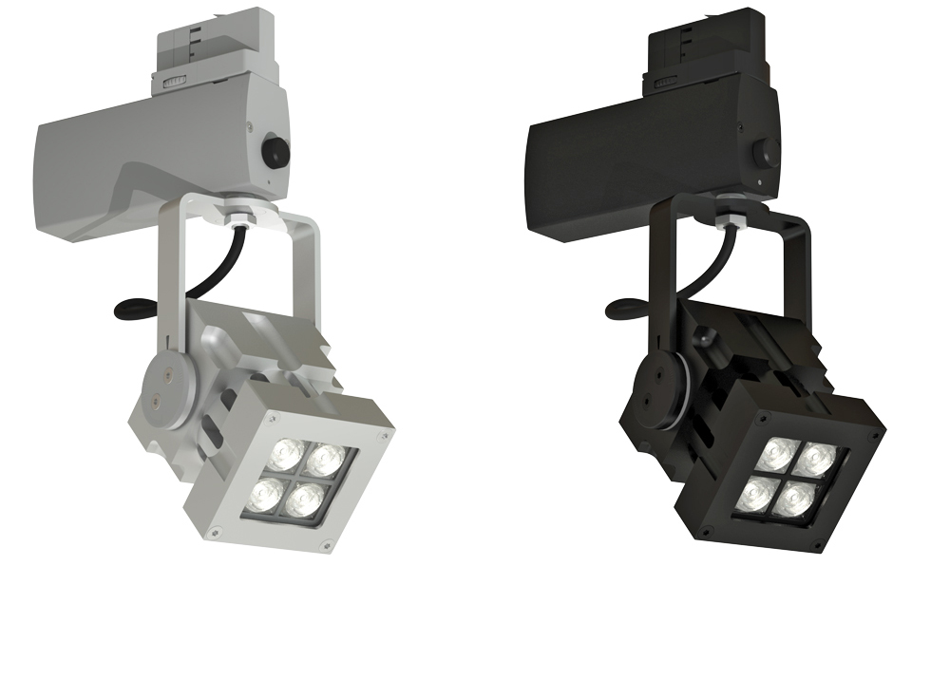
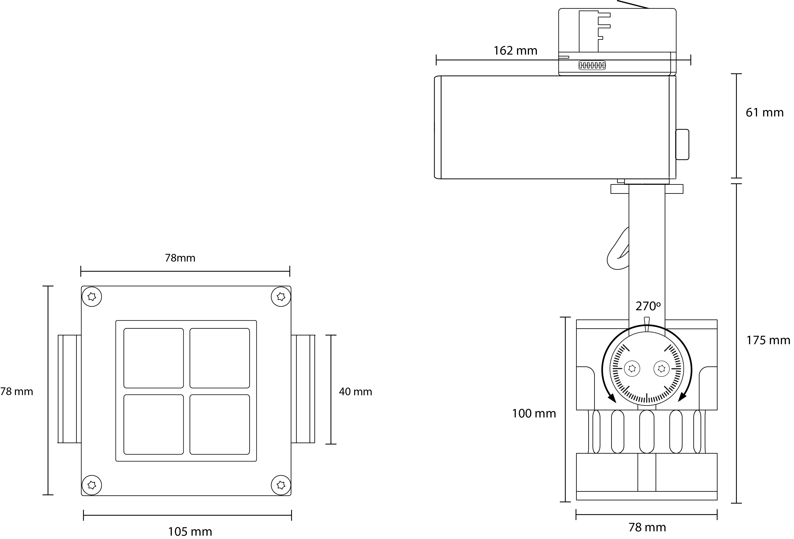

CLS REVO Compact Gallery track spot
Type | : | 10 Watt IP40 aluminium track spot
Colour | : | Blank or black anodized aluminium
Material | : | Massive CNC machined aluminium
Weight | : | 1500 gr
IP Rating | : | IP40
IK class | : | X
Optics | : | Configurable: 8°, 12°, 30°, 61°, 80° or 12 x 46° beam angle
Light source | : | Lumileds High Power LED: 4 x Luxeon T
Colour Temperature | : | 2700K, 3000K, 4000K, 6500K, amber, blue, red
CRI | : | >80
Drive current | : | 700 mA
Driver | : | Internal power supply
Power factor | : | >0,90
Dimming | : | Through potentiometer on driver housing
Remarks | : | Choice of Global or Eutrac rail adapter
Optional accessories | : | Rail products, snoot
Connection | : | 3 phase track adapter
Life time | : | Up to 50.000 hours
Warranty | : | 3 years warranty
Origin | : | Designed and manufactured in The Netherlands

