
CLS REVO Track Colour Flow DMX-8
Type | : | 20 Watt IP20 colour changing aluminium track spot
Colour | : | Blank or black anodized aluminium
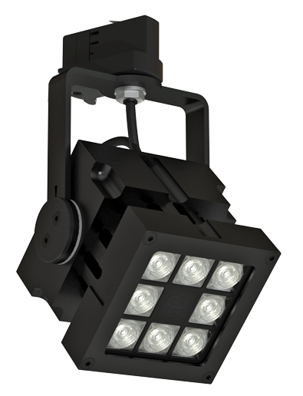  Material | : | Massive CNC machined aluminium
Weight | : | 1900 gr
IP Rating | : | IP20
IK class | : | X
Optics | : | Configurable: 8°, 12°, 30°, 61°, 80° or 12 x 46° beam angle
Light source | : | Lumileds High Power LED: 8 x Luxeon Rebel
LED colour | : | RGBA, RGBW or AWB
CRI | : | >99
Drive current | : | 700mA
Driver | : | Internal power supply: 100-240 VAC
Power factor | : | >0,92
Control | : | DMX512 protocol
Remarks | : | No extra cabling needed  Calibration functionality
Optional accessories | : | Rail products, snoot, magnet
Connection | : | 3 phase Track adapter
Life time | : | Up to 50.000 hours
Warranty | : | 3 years
Origin | : | Designed and manufactured in The Netherlands



