
CLS REVO Track Magno individually dimmable spot
Type | : | 20 Watt IP20 aluminium track spot with Magno dimming
Colour | : | Blank or black anodized aluminium
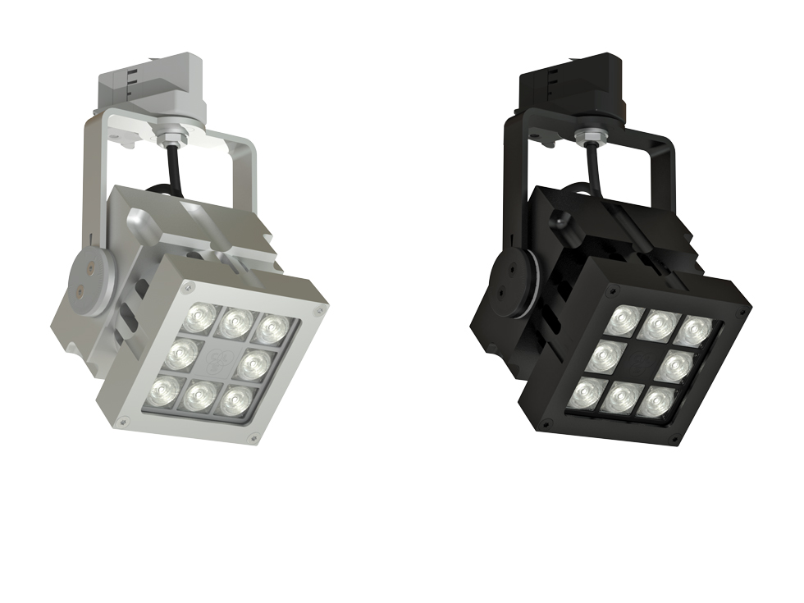  Material | : | Massive CNC machined aluminium
Weight | : | 1900 gr
IP Rating | : | IP20
IK class | : | X
Optics | : | Configurable: 8°, 12°, 30°, 61°, 12 x 46° beam angle
Light source | : | Lumileds High Power LED: 8 x Luxeon T
Colour temperature | : | 2400K, 2700K, 3000K, 4000K, 6500K, amber, blue, red & green
CRI | : | >80
Drive current | : | 700mA
Driver | : | Internal power supply: 100-240 VAC
Power factor | : | >0,92
Control  Dimming | :  : | Magno Dimming  Magno dim system
Remarks | : | Magno dimming offers the facility of individually dimmable fixtures without the need for any control equipment.  No extra cabling needed.  Calibration functionality.
Optional accessories | : | Rail products, snoot, magnet
Connection | : | 3 phase Track adapter
Life time | : | Up to 50.000 hours
Warranty | : | 3 years
Origin | : | Designed and manufactured in The Netherlands



